Nicholas Golden

Game Design Document: “Vela the Star Hunter”

Prototype Link: <https://www.dropbox.com/s/4agtwqhnuhv2v8m/Vela%20the%20Star%20Hunter%20Prototype.zip?dl=0>

Github Source Code (Unreal Engine 4 v4.19):

<https://github.com/ngolden5/VelaPrototype>

Instructions:  
1. Download the Zip.

2. Extract the files.

3. Run “Vela_Proto.exe”

4. The game will start in fullscreen borderless and may activate SteamVR (SteamVR is not necessary to run the game. It just opens it for some unknown reason.)

5. Use WASD or arrows to move and jump, left click or space is to fire weapon.

6. There’s no menu or windows to close the game, so you’ll have to either press the Start button and close the program from the task bar, press Ctrl+Alt+Del and close it via task manager, or press Alt-F4 to close it.

Title

* Vela: The Star Hunter
* Named after the main character, and her profession in where it is (the stars aka space).

Genre

* Action/Platformer, Space Opera, Metroidvania/Mega Man-like, 2D-Platformer

ESRB

* E10+

Platform

* Windows/PC.

Target Audience

* Platformer-players, average-above average skill level.

Character

* Main character, who’s a mercenary, is on a quest of revenge to fight the final boss of the game.

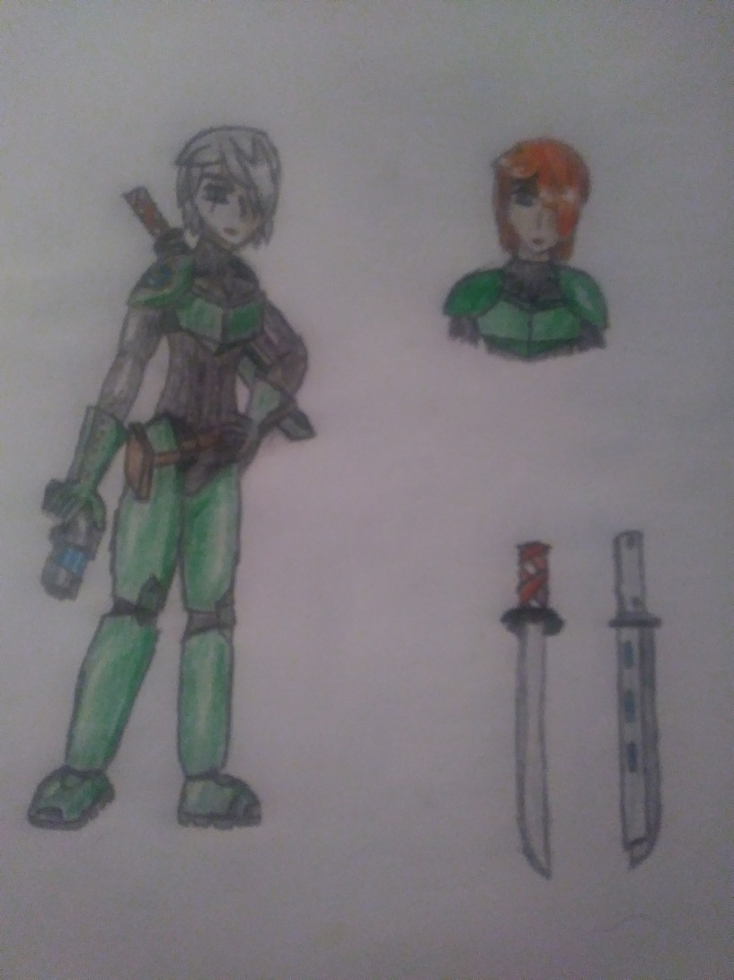

* More info in character design.
* Vela is her first name. Last name is shrouded in mystery.

Story

* Each of the worlds has a subordinate of the final boss. Your character must defeat them to progress.
* Main character, who’s a mercenary, is on a quest of revenge to fight the final boss of the game.
  + Vela is a mercenary for hire, that fights via contracts.
  + A friend of hers is a scientist that builds and creates technology she uses to fight with.
  + He’s working on a type of adaptive power armor that is capable of incorporating enemy weapons and other features. The armor is called the “Chimera Armor”.
  + He’s finished building a prototype long ago, and he has the completed model that he’s given to Vela where she tests it on a relatively quiet forest with training drones (this is the tutorial).
  + The scientist gives cues to Vela via remote communications from his lab that’s fairly far away (potentially on another planet)
  + While she’s testing it, the scientist’s lab is raided. He is killed in the battle and his prototype armor is stolen. (Later on, it will be revealed that the villain who ordered the armor to be stolen was not aware that a complete version was available and assumed the prototype was the only available version)
  + She embarks on a quest of revenge to avenge the scientist while coincidentally also being handed a contract by a corporation who had some investment in the scientist.
  + She travels to various locations to hunt down the villain’s (name is Leo) henchmen. A rival (name is Orion) who appears to be her equal in skill is hired by the villain
* The tutorial features Vela and a scientist who’s working on a special power armor. The scientist is assassinated and a prototype armor is stolen.
  + Once you’re past the tutorial, there is freedom in choosing which worlds to travel to.
  + Defeating the boss will net you an tool that you can use to upgrade your power armor/equipment with.
  + There might be other powerups hidden in puzzle solving or clever places in the levels.
  + There will also be opportunities to collect money from enemies and the environment in levels which can also be used to buy upgrades (these are the same upgrades as above)
  + You are limited in the number of upgrades you can equip, to give a sense of customizability while also preventing unlimited power gain.
  + Once you beat all the available levels, the final stage will open and you will challenge the rival and villain as the final boss.

Game World

* (Potentially for the future, but not now) Platformer through multiple unique worlds. Multiple worlds with various scenery/themes. Estimated between 2-4 to start with, options for 2-4 more other worlds may be designed at a later time.
* For the purposes of the game design class, most of the effort has been focused on the space prison stage.
  + Start with only 1 since it’s a single person project, and use that as a stepping platform to build the others.
* One of the stages is a space prison that is nearly impossible to break into.

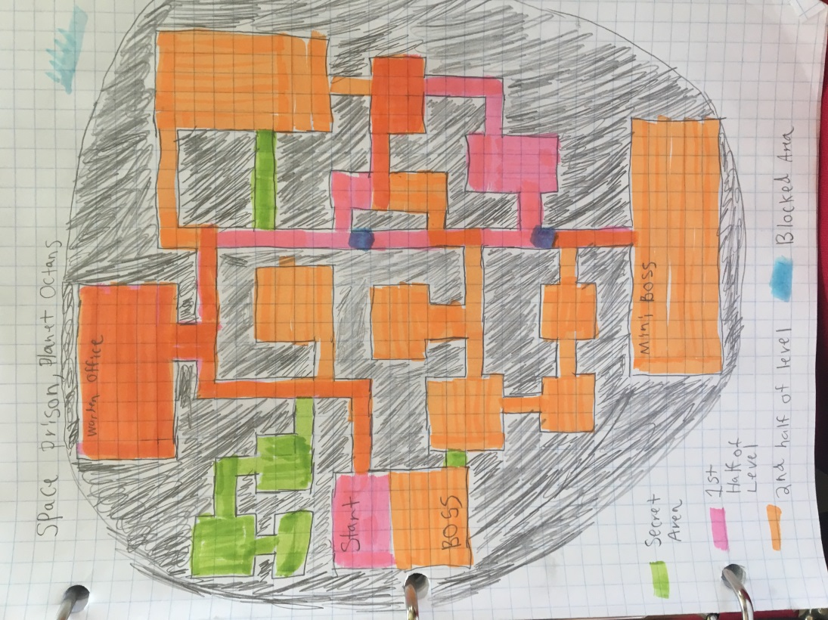

* + Space prison: You start in the prison’s hangar (in the middle) and fight your way through riots and prisoners to the warden’s office (at the top of the prison), after meeting with the warden you need to go to the high security section to find your target (at the bottom) when you get there fight the mini boss and find out the prisoner escaped and damaged the gravity shields, work your way back to the warden’s office with the gravity flipped after the warden’s office you make your way back to the hangar where you fight the boss.
  + Vela gains access through her contract with her corporation.
  + While she’s visiting, a prison break/riot breaks out, and she must traverse part of the stage and help deal with the prisoners (they will be the basic enemy)
  + After Vela progresses to the mini-boss, the level will go to a “phase 2” where some prisoners have successfully overwhelmed the guards and are taking control of the facility. Security camera and some minor defenses will start to target Vela. The player can choose a straightforward approach or can choose to use stealth if they’ve gotten the upgrade.
  + In terms of architecture, the interior of the level resembles that of a traditional brick and mortar prison without windows. The reason is that it’s meant to impose a psychological effect on the prisoners to demean them. The guard rooms are significantly more advanced and befitting of the science-fiction genre.
  + Riots will be happening in the first half of the stage, and a hostile takeover in the 2nd, which will culminate in a boss fight with a strong, dumb muscle kind of personality at the end.
* There will be many constellation names used throughout the game for thematic purposes.

Gameplay

* Gunplay elements, similar to the Mega Man games or Metroid to a lesser level. As far as mega man goes, I’m referring more to Zero’s gameplay in particular, with a gun and a sword.
* Lots of movement options for our main character would be ideal. Wall jump, crawl, double jump, etc. Maybe unlock more movement abilities as you progress or find them hidden in the levels.
* Mega Man Zero-like combat gameplay.
* Instakill moves are a massive no-no, especially when it's not even end game.
* Game will be slightly challenging. Solutions can either be beaten with high skill or creative use of the weapon loadouts.
* Customizable weapon loadout which introduces strategy and creativity to the otherwise sterile platformer genre.
* 2.5D navigation. It’ll be a 2D platformer, but at certain points there will be options to take different paths, and there’ll be an arrow indicator and keypress to set the current direction to follow.
  + Alternatively, some places might have split paths that can diverge into different rooms and such.

User Interface

* Toned-down version of the main character’s colors so as to not be too distracting.
* UI: A sleek minimalistic design that leaves a good amount of space for viewing. Multiple menus will be available from the main pause/save game menu to other menus such as the customization screen. Cues will be available on screen at points and will help direct the player.

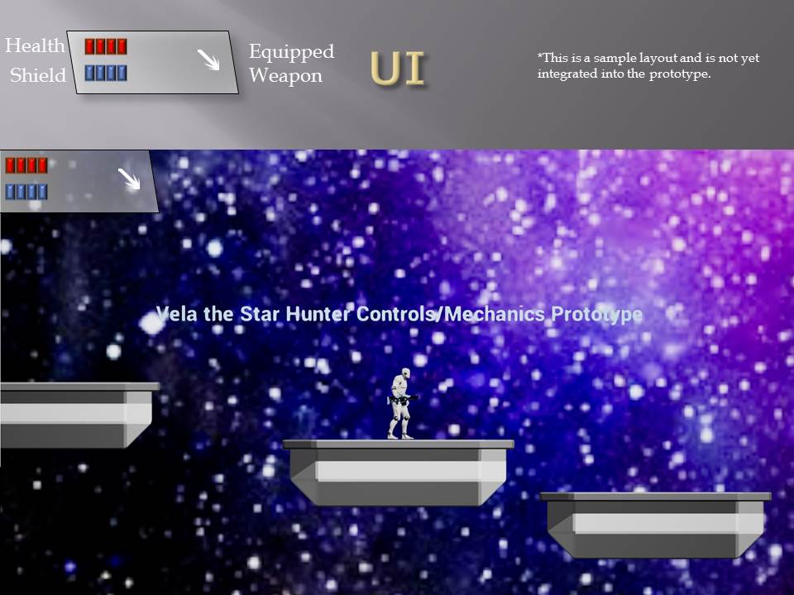

* *Colors are not final, character model is not final, UI is not final.

Level Progression

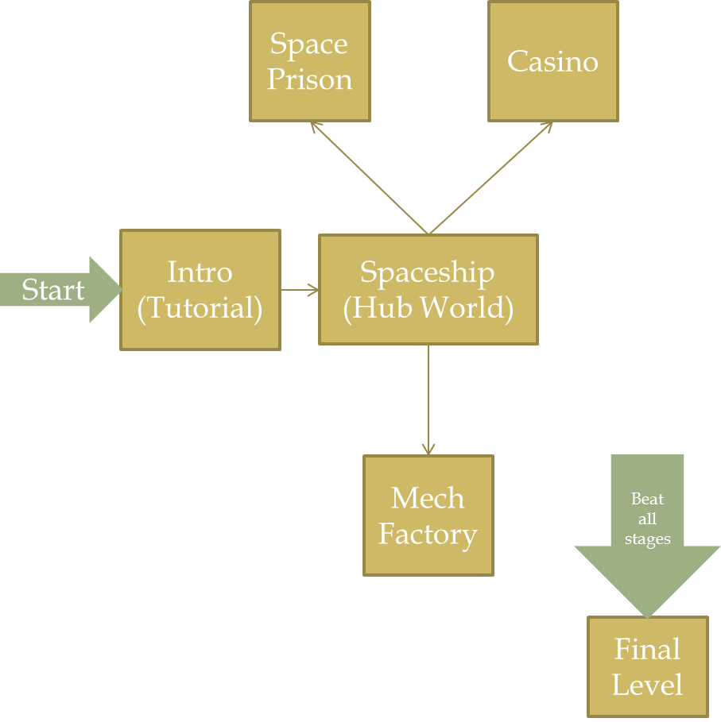

* You start at a tutorial intro world which is explained in depth within the ‘story’ section. You then get to your spaceship which acts as a hub world and transports you to other worlds (like the spaceship in Super Mario Galaxy).
* These worlds currently consist of Space Prison, Mech Factory, and Casino.
* The first 2 have been explained in some depth, with a focus on the Space Prison.
* Once all the worlds are beaten, a Final Level will unlock.
  + There may be optional levels that are not required to be beaten to progress to the final level.
* Each world is unique and may have varying ways of progression.

Technical capabilities and limits

* Limited manpower, general knowledge in various aspects of game design but no specializations outside of programming.
* I only have high school level art training. None of which is for digital art.
* Limited programming knowledge.
* Lack of time.

Art Bible

* Sprite-based with an anime-esque style is how I’d prefer it to look.
  + Examples of this style would be Mega Man X/Zero, Metroid (kinda), Shantae, etc.
* Space theme, various kinds of planets in a single solar system, possibly with accurate planet types and positions (example, gas giant in the further reaches of the system). Enough to feel deep, but not so much as to make it feel like realism is a major component.
* I pretty much 100% don’t want to have any sort of super colorless, boring art style.
* I want the game to be more vibrant and colorful.
* Super realism is boring. Stylism. It’s “Space Opera”, not gritty sci-fi.
* Sample boss designs:

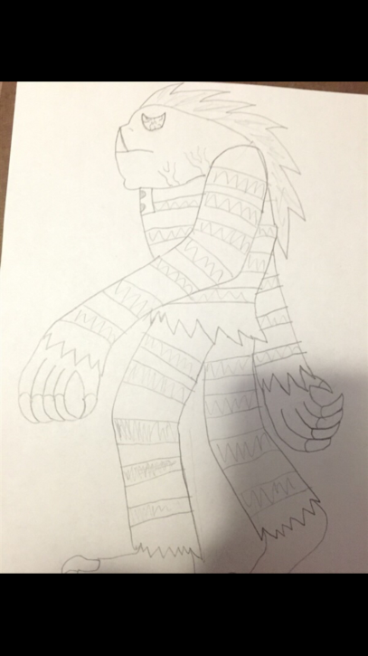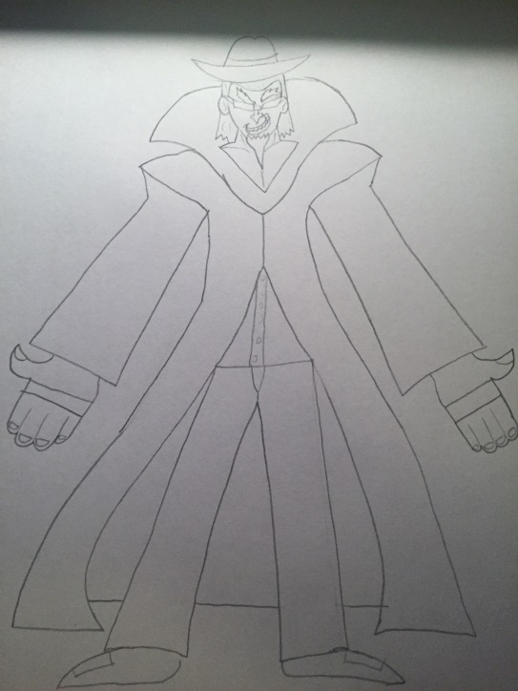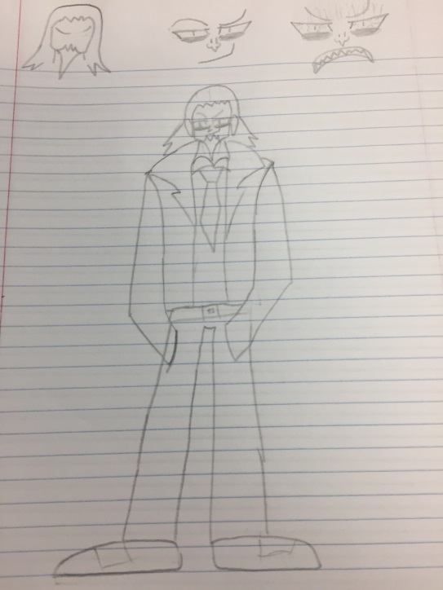

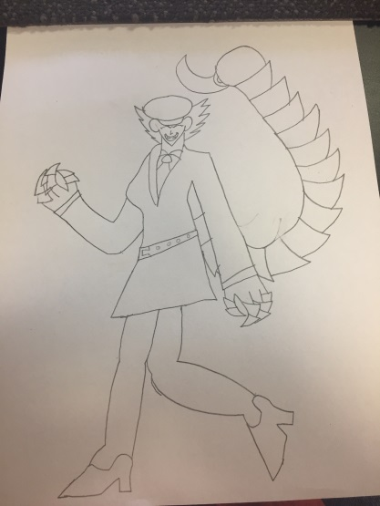

Character Design

* Name is Vela: female main character with a motive of revenge.
* MC: No-nonsense, mercenary type in terms of personality and outlook?
  + Armor visually is similar to the likes of Samus Aran’s suit from metroid, but differentiated by color scheme, the shape of parts of it, and go with it not having a physical helmet.
  + The suit shouldn’t be super bulky if going with a mobile style of combat and platforming, so nothing like a Brotherhood of Steel member or something.
  + For the melee weapon she should have the attacks be fast and fluid, something like a katana or a laser sword, anything lending well to a quick style of fighting. Katana is my preference though, since it differentiates our character from Zero, who we’re seemingly already taking enough visual cues from.
* Factory Stage Boss
  + Backstory:  
    Race: Human  
    Hailing from and currently headquartered on the practically corporate-run urban world of (?), she is the CEO of one of the top weapons manufacturers, dealing in guns, ships, warheads, and more recently experimental (mecha) and selling to anyone with the bankroll to afford it, including terrorist and insurrectionist factions. Hardly remorseful, she has long harbored a belief in survival of the fittest, thinking it is simply human nature to suppress the weak and helpless. Thanks to her numerous governmental ties, very little can or has been done about the corporation’s numerous illegal and unethical practices. She has recently entered into close partnership with (bad guys) in hopes of lucrative ventures.
  + Wears professional business attire (i.e. business suit). Pilots a mech which will be what you’re actually fighting in their fight, rather than them being on foot. Mech would attack with frontal guns and missile launchers, maybe also having a melee option that it would use if you stay too close to it for too long.
* Boss Idea for a world: Female Dictator with a Mechanical Scorpion Tail. (Look under Art Bible for a reference)

World Design

* Very much a sci-fi game. Lots of cool, technological stuff.
* One idea is like a Steam Punk-esque Level on a gas giant planet.
* Factory/City level: Highly technologically advanced city with flashy signs and billboards, yet strewn with trash and appearance of low quality of life. Halfway through becomes a massive factory complex. Houses a major mech factory.
  + Think Blade Runner and such for how the city half would look.
  + Pretty, bright alpine scenery marred by an artificial skyline with smog, machinery, and billboards, leading to a large, sprawling mech weapons factory full of production equipment and finished and unfinished mechs.
  + Mech Factory
    - One level Gimmick will be Venting Chemical Gas Filled portions of the level. Inhibiting Vision, and hurting the character if inside of it too long.
    - Another level will be pretty flat, with platforming options to get over certain enemies and gas areas.
    - Also, Level Event 1: Mini-Boss comes out of the first Gas portion-Character has to fight it.
    - Level Event 2: After turning off the gas (which are the vents helping with keeping the thing afloat on the Gas Giant)
    - The level becomes timed, because the mech factory is building an ultimate mech that will be completed soon.
* Space prison level with design similar to:

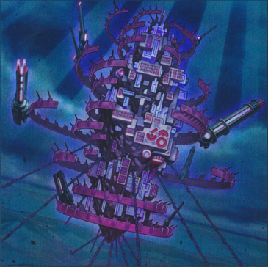

* + An ellipsoid city with floating in the atmosphere of a gas giant where the gravity is too intense for usual spacecraft, the only way in is to use the prison transports, both the transports and the prison have gravity shields around them to stabilize the G-force
  + Very blocky, indicates cells. Inside looks very classic prison like with no windows. Meant to invoke a dark, very “Jail/Prison” environment so as to make the prisoners aware of their environment and their imprisonment at all times.
  + Guard “towers” and armories are significantly more hi-tech looking. The guards don’t need to be reminded they’re in a prison. Much more sci-fi looking.

Sound Design

* Music done in the style of old chip-based music. (i.e. SNES or Genesis) with some modern touches and flairs. Think *FTL*’s soundtrack as an example.
* “Cool” sounding music for certain scenes and something more upbeat during low-tension stages
  + A spaceish soundtrack (synths, some orchestration, a mix of sci-fi sound effects)
* The mech factory will have techno synths (square synths) along with heavy, grunge metal sound parts (think FTL’s soundtrack of the final battle or Engi space and it has cool techno parts but with deep, more metallic/harder parts)
* The space prison will be a foreboding yet tense theme fitting the environment and ensuing chaos.

Script

* Preferably kinda serious but not super angsty/edgy, with some actual humor on occasion.
* A more lighthearted with serious parts at points. Think Megaman in terms of seriousness. There are serious parts, but it’s not depressingly serious.
* Most of the script is covered in the story.

Software Engineering

* Windows compatibility, 7,8,10 anticipated development platforms. Use of game engine is recommended for compatibility, Unreal Engine may be a viable choice. Potential to expand to Mac OS X, and Linux are not in initial development but may be planned for later. 32 or 64 bit, the low amount of processing power will probably leave flexibility for this.
* Spriter Pro software for Sprite design
* Unreal Engine 4 for game engine because it’s what I have the most experience in.
* FL Studio for music design.
* Powerpoint and Word for storyboarding and document creation.

Marketing Strategy

* Social Media, Word of Mouth

Project Management

* Bi-weekly updates with a panel to discuss choices and to record them on paper for review. A team leader will mostly be keeping the conversation from getting derailed and to help keep everyone on track.